Project Initialization and Planning Phase

Date | 14 JUNE 2026
Team ID | xxxxxx
Project Name | Sustainable Waste Management Assistant Using Generative AI
Maximum Marks | 3 Marks

Define Problem Statements (Customer Problem Statement Template):



Create a problem statement to understand your customer's point of view. The Customer Problem Statement template helps you focus on what matters to create experiences people will love. A well-articulated customer problem statement allows you and your team to find the ideal solution for your customers' challenges. Throughout the process, you’ll also be able to empathize with your customers, which helps you better understand how they perceive your product or service.

Example:
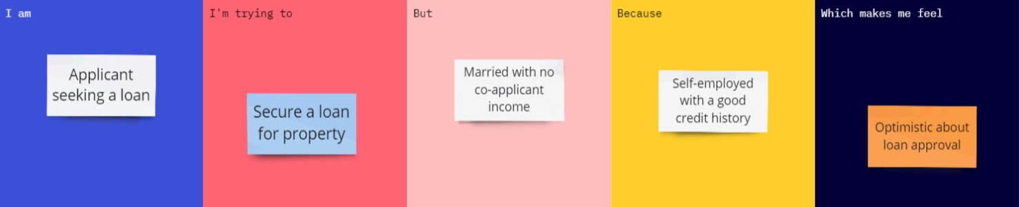

Problem  Statement  (PS) | I am (Customer) | I’m trying  to | But | Because | Which makes me feel
PS-1 | An urban resident who wants to dispose of household waste responsibly. | Identify waste items and learn the correct disposal or recycling method | I often don’t know whether an item is hazardous, recyclable, or where to take it. | Waste categories and disposal rules are complex, and collection centers are not easy to locate. | Confused, worried about harming the environment, and eager for a simple, trustworthy guide..

